# Experimental design:

We built a model of dialogue which is capable to have a cooperative negotiation with a user. Moreover, we allow our system to adapt its negotiation strategy in function to the perceived relation of dominance with the other.

In order to understand better how the dominance behavior can appear in the dialogue, we conducted an experiment in which we asked participants to read dialogues generated with our model. The model produces a dialogue of cooperative negotiation where two agents have to decide in which restaurant they will go dinner. The behavior of each agent is affected by its perception of his relation of dominance with the other agent.

Explain here the three principals of dominance

We designed our agents to follow three different behaviors of dominance*: dominant, submissive and a peer agent.* We generated two types of dialogues: dialogues in which agents have **unbalanced** relation of dominance (*dominant* agent dialogues with *submissive,* and dialogues with **balanced** relation of dominance (two *peer* agents). Because the preferences affect directly the flow of the negotiation, we initialized agents with different types of preferences model. For each dialogue, agents are initialized with either **similar** preferences or in the contrary **different** preferences that we reverse to observe for the same preferences how the relation of dominance changes the behavior of agents. For example:

1. *Dialogue1: Dominant agent initialized with the model of preferences S1, and submissive agent initialized with the model of preferences S2.*
2. *Dialogue 2 which is the reverse of dialogue 1: Dominant agent initialized with the model of preferences S2, and submissive agent initialized with the model of preferences S1.*

We obtain at the end eight dialogues in which we aim to analyze how the behavior of each of three agents shows in a dialogue. Thus, three conditions we manipulated.

In **condition 1,** we analyzed the dominant agent behavior during all the different dialogues. In **condition2**, we analyzed the peer agent behavior for all the dialogues. In **condition 3**, we analyzed the behavior of the submissive agents for all the dialogues.

# Hypotheses:

Agent behaviors were modeled based on three principals from existing social psychology theory. Based on these principals, we developed three hypotheses:

* **H1:** Participants will perceive submissive agent as more interested to the other preferences than the peer agent in decision making, while dominant agent will be perceived a self-centered.
* **H2:** A dominant agent is perceived as more demanding than the peer agent and the submissive will be perceived as flexible.
* **H3:** A dominant agent is perceived as the leader of the dialogue more than the peer agent. The submissive agent is perceived as a follower.

# Pre-experiment:

We conducted a between-subjects pre-experiment, with two dialogues. The first dialogue was set between a *dominant* agent and a *submissive* agent initialized with different preferences. The second dialogue concerns two *peer* agents with similar preferences.

Participants were asked to read the dialogues. They answered next to a questionnaire that measures their perception of agent’s behaviors during the dialogue. For each hypothesis, we defined two questions that measure the participants review for each agent. We had a total of 12 questions related to the relation of dominance and two manipulation check questions.

A total of 20 subjects participated to the pre-experiment (10 per dialogue). We excluded 4 subjects who incorrectly answer to manipulation test questions. (1 for the first dialogue, and 3 for the second one).

## Statistical study:

We first collected the answers given by the subjects for each question, that we sorted by agent (*dominant, peer, submissive).* Therefore, for each agent type, we gathered subjects perception of the dominance behavior. For the pre-experiment, for all the dialogues, we obtain for each question (of 6 in total), 9 answers for *dominant* and *submissive* agents, and 14 answers for *peer* agent.

To analyze behavioral data, we applied a T-student analysis for **independent** **variables** to compute if there is a significate difference among agents behavior for each question. As data was gathered from different dialogues, we consider them as independent variables for the T-student. However, for the experiment, data for the *dominant*and*submissive*agent were collected from the same dialogue. Thus we applied a **paired** T-student to compare the submissive and dominant agents.

In order to be able to compute the T-student, data must have a **normal distribution.** For the pre-experiment, data don’t follow a normal distribution due to small size of the sample.

We present the obtained results for each hypothesis. Indeed, for each hypothesis we defined two questions: One question and its reverse. We computed the average of agreement for each question and the standard deviation

# H 1 : Taking in account the preferences of other.

The analysis showed that for the first question, there is no significant difference between agents behaviors (see fig 1.a). For all the cases p>0.05, even if in average subjects agree that the *submissive* agent consider the preferences of other in decision making more than the *peer* and *dominant* agents. While, for the second question (Reverse question), they highly agree that the *dominant* agent only consider its preferences (*p = 0.01 for dominant Vs peer, p<0.001 for dominant Vs submissive)*, and the *peer* agent considers his preferences more than the *submissive* agent (*p =0.01).* We should consider the difference between the preferences of agents in the same dialogue. If agents share the same preferences, the notion of concession of preferences won’t be highlighted in the dialogue.

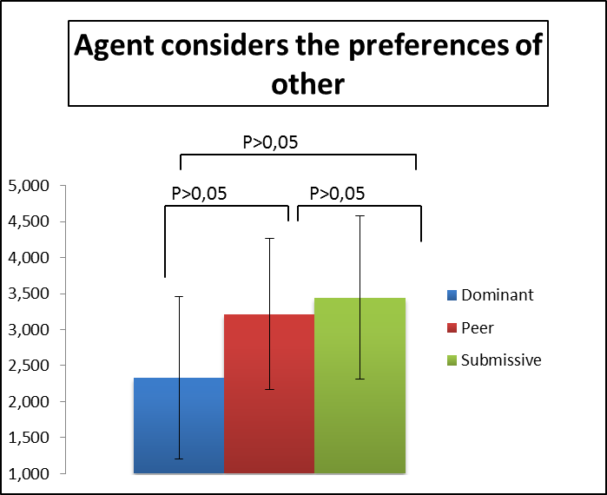 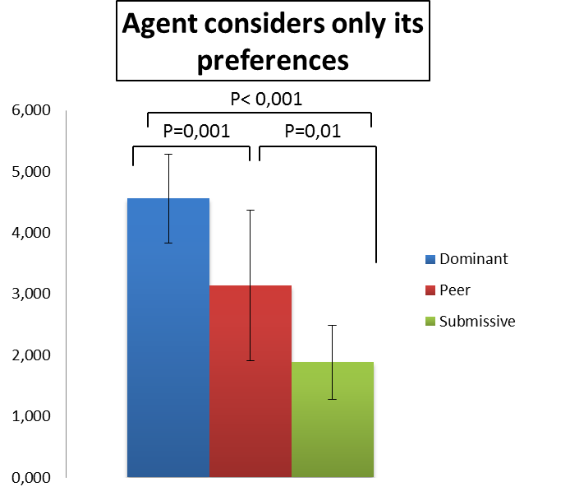

**(b)**

**(a)**

**Fig 1.** Analysis for **H1** hypothesis.

# H 2: Level of demand concerning the choice of the restaurant.

The results give support for only one question of the hypothesis H2. Indeed, for the question “agent is demanding” there was no significant difference observed among the three agent (for each case *p>0.05)*. While for the reverse question, *dominant* agent was rated as being **less flexible** than the *peer* and *submissive* agent. This difference of perception between the two questions might be related to a wrong understanding to “the notion of **demand”** in the question in fig 2.a.

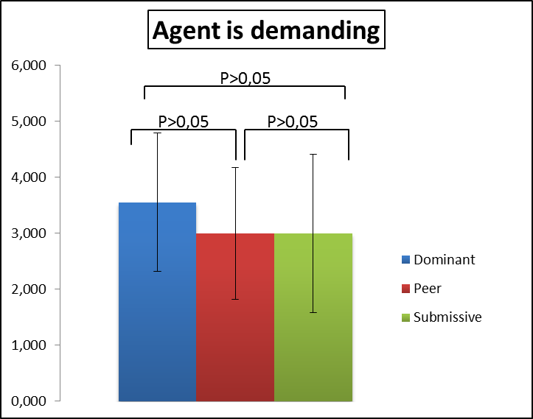 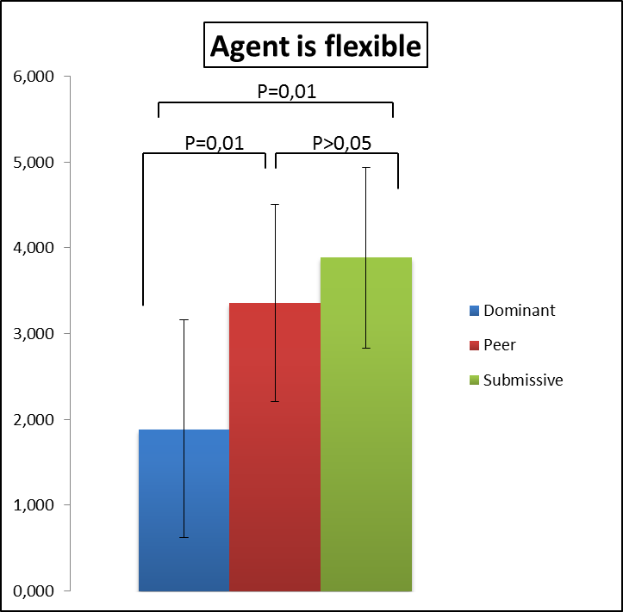

**(b)**

**(a)**

**Fig 2.** Analysis for **H2** hypothesis.

# H3: Who leads the dialogue

The analysis confirmed our third hypothesis. For the question “who leads the dialogue”, *dominant* *agent* was perceived as more leading the dialogue than the *peer* and the *submissive agent (p=0.01)* as presented in figure 3.a*.* In the contrary, *submissive agent* was perceived as being leaded in the dialogue compared to the *dominant agent (p<0.01).*  However, there is no significant difference between the *Peer* and the *submissive* agent as presented in figure 3.b.

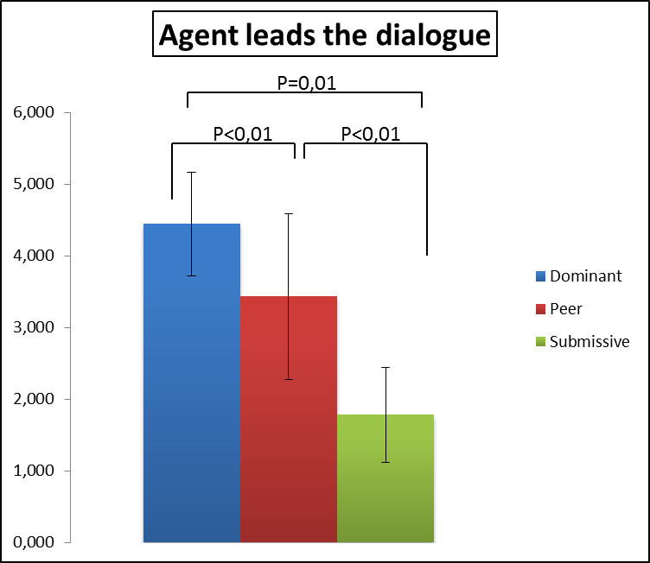 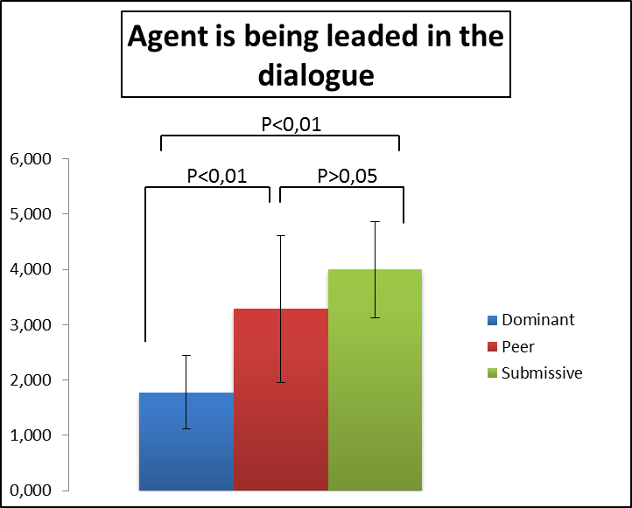

**(b)**

**(a)**

**Fig 3.** Analysis for **H3** hypothesis.

Further experiments will be lead with more dialogues and participants in order to confirm these first results.